Order #15386
Riski | Product 1 of 1: Embroidered Sleeve Inner & Gown Abaya Set | 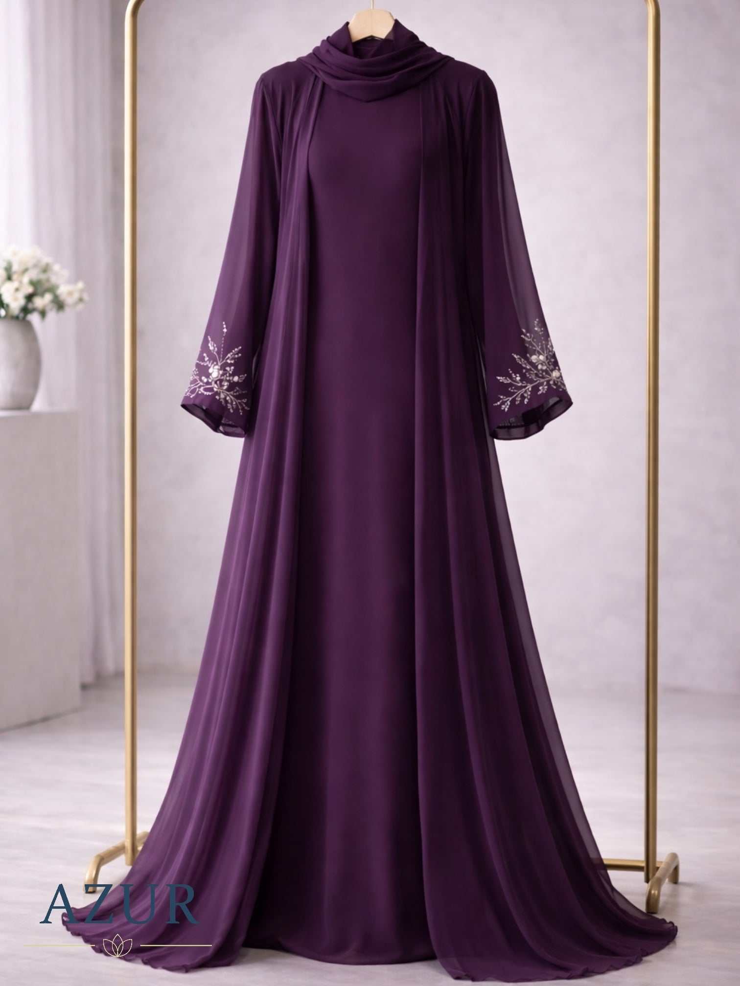
NAME | rayyan rayyan
NUMBER | 03404439550
ADDRESS | hayatabad phase 1 sector D3 street 10 house 50, peshawer, Pakistan
SIZE | Xlarge
S. STRUC
AMOUNT | 9,500.00 PKR
TAGS | Call Confirmed

Order #15385
Riski | Product 1 of 1: Two-Tone Double Georgette Coat Abaya | 
NAME | Rabia Farooq
NUMBER | +923356193332
ADDRESS | 88/1,31st street ,, dha phase 5..khayaban e seher, Karachi, Pakistan
SIZE | Large
S. STRUC
AMOUNT | 6,500.00 PKR
TAGS | Call Confirmed

Order #15384
Riski | Product 1 of 1: Elegant Cape Gown Set – 3 Piece (Double Georgette) | 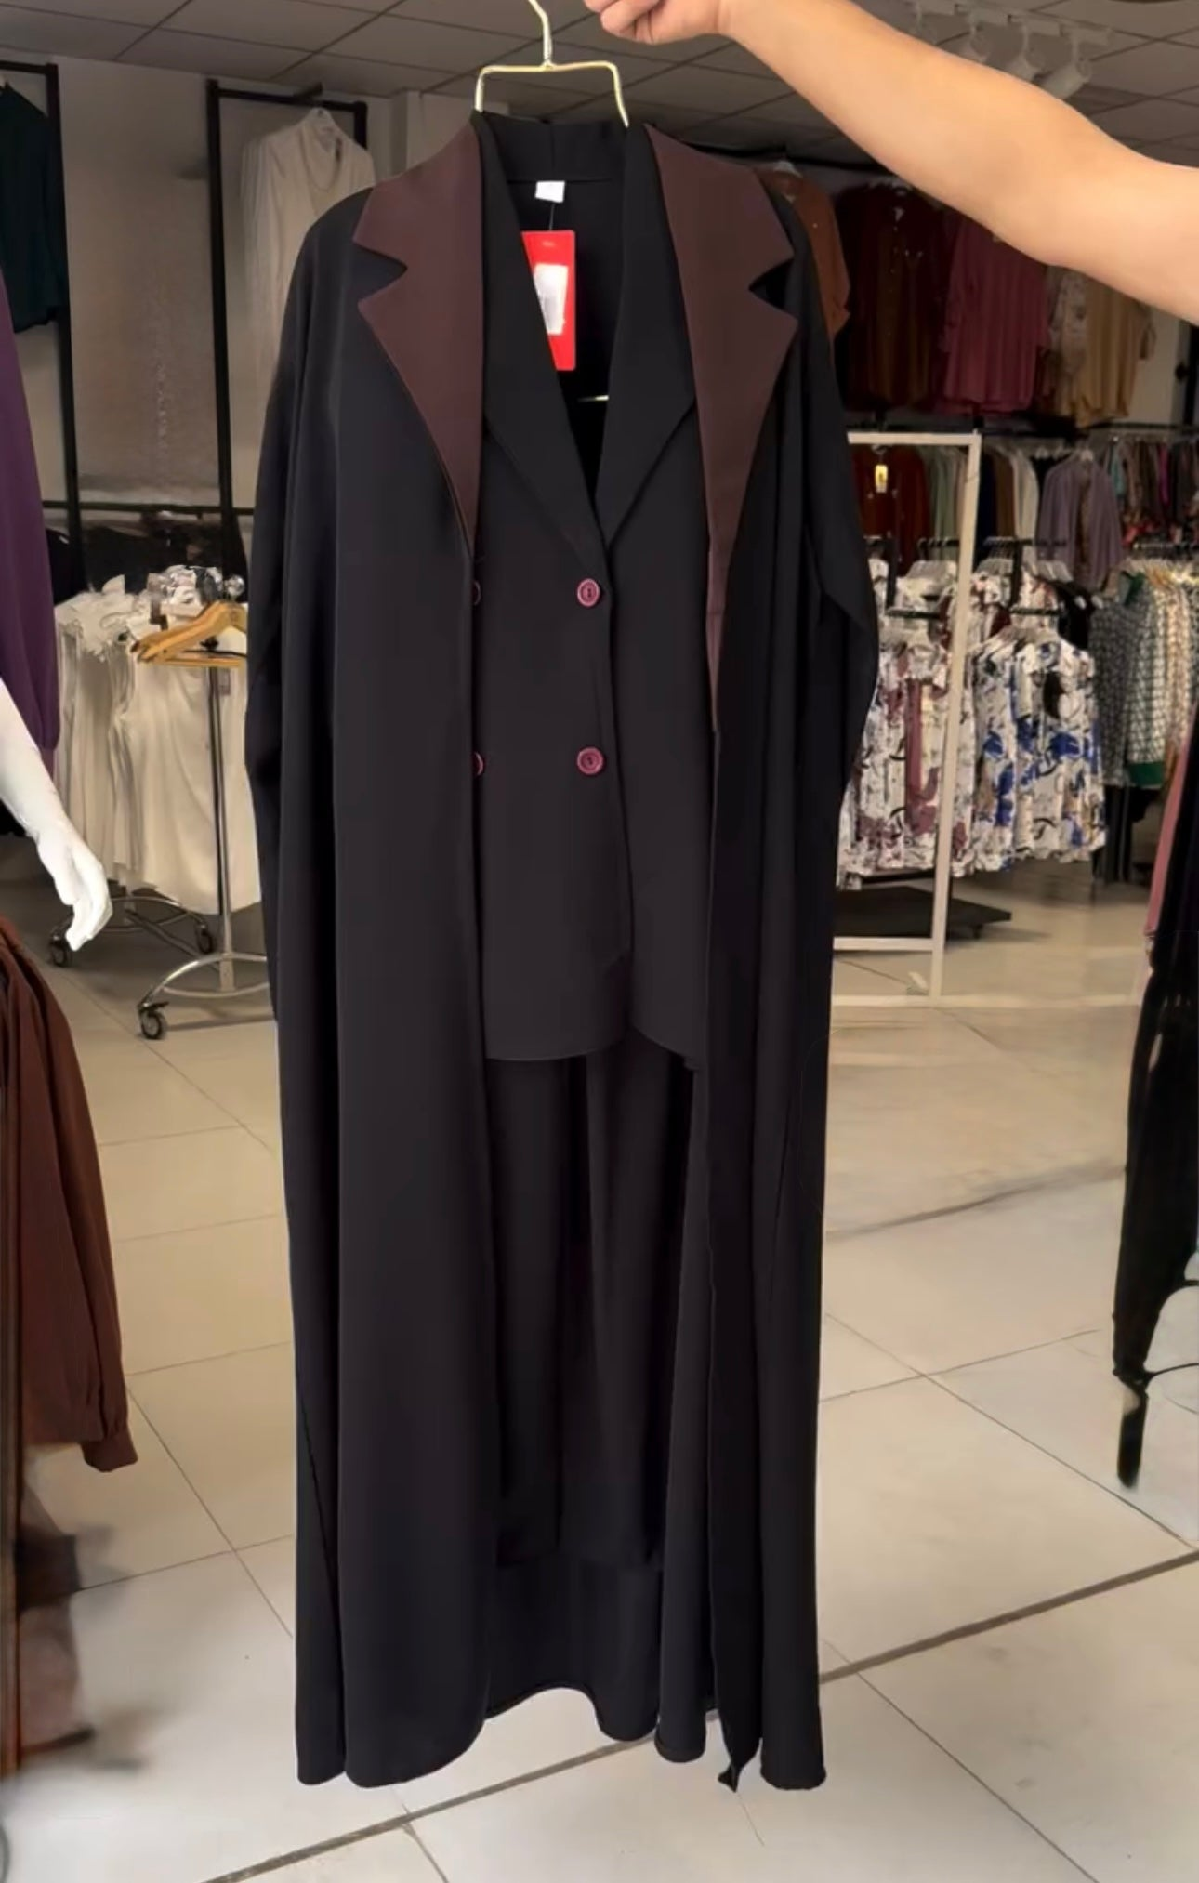
NAME | Rabia Kariman
NUMBER | 03223995764
ADDRESS | Ranger road sheikh colony butt street, Sialkot, Pakistan
SIZE | Xlarge
S. STRUC
AMOUNT | 6,500.00 PKR
TAGS | Call Busy

Order #15383
Riski | Product 1 of 1: Elegant Pearl-Embellished Silk Gown | 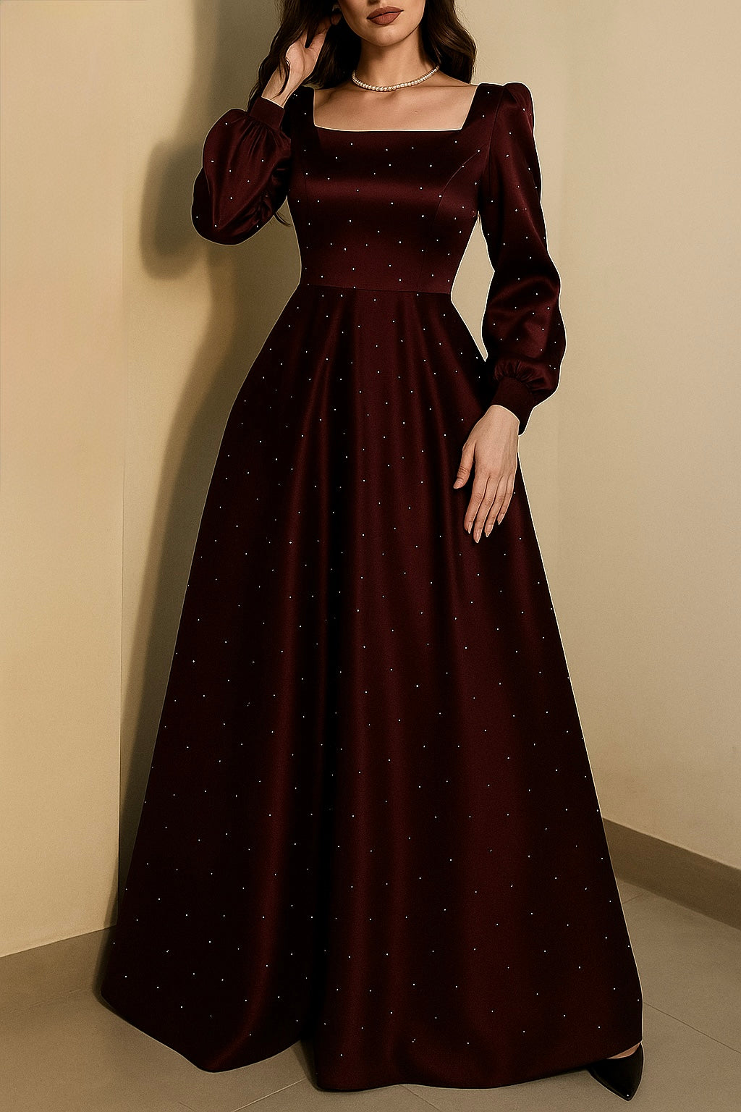
NAME | Tayyaba Tariq
NUMBER | 03234671607
ADDRESS | House:20 Block:c Lahore Canal Bank Housing Society Thokar Niaz Baigh, Lahore, Pakistan
SIZE | Small / Maroon
S. STRUC
AMOUNT | 7,500.00 PKR
TAGS | Call Confirmed

Order #15382
Riski | Product 1 of 1: Elegant Double Georgette Inner Dress with Overcoat Gown | 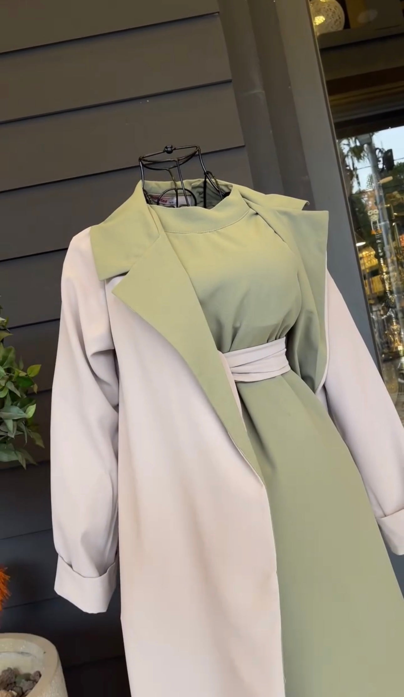
NAME | Rana Saleem
NUMBER | 03231597238
ADDRESS | Chandni Chowk 41c Satellite Town Rawalpindi, Rawalpindi, Pakistan
SIZE | Xlarge / Brown
S. STRUC
AMOUNT | 6,500.00 PKR
TAGS | Call Busy

Order #15381
Riski | Product 1 of 1: Two-Tone Flared Double Georgette Abaya | 
NAME | Nabeel Abbasi
NUMBER | 03002188662
ADDRESS | Lohar muhalla near post office pir jo goth, Pir jo goth, Pakistan
SIZE | Medium / Blue
S. STRUC
AMOUNT | 5,500.00 PKR
TAGS | Call Busy

Order #15380
Riski | Product 1 of 3: Matching Stole | (No image available)
NAME | Khawar Khoso | (No image available)
NUMBER | 03312020722 | (No image available)
ADDRESS | House A13 makhdoom Bilwal cooperative housing society korangi industrial area Karachi, Karachi, Pakistan | (No image available)
SIZE | N/A | (No image available)
S. STRUC |  | (No image available)
AMOUNT | 1,500.00 PKR | (No image available)
TAGS | Call Busy | (No image available)

Riski | Product 2 of 3: Double Georgette Inner and Gown Abaya | 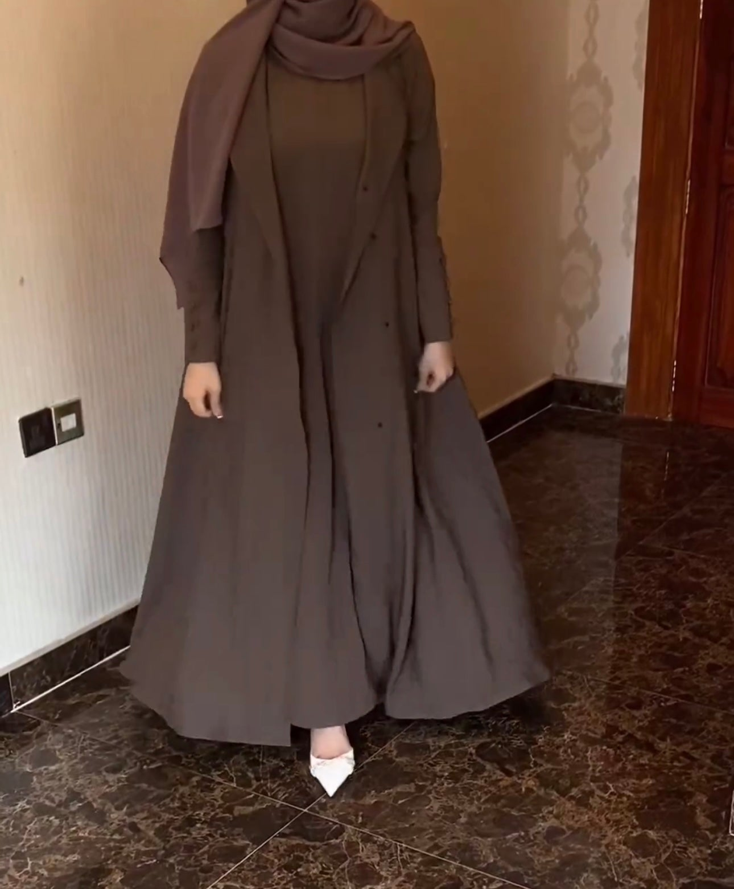
NAME | Khawar Khoso
NUMBER | 03312020722
ADDRESS | House A13 makhdoom Bilwal cooperative housing society korangi industrial area Karachi, Karachi, Pakistan
SIZE | Xlarge
S. STRUC
AMOUNT | 6,500.00 PKR
TAGS | Call Busy

Riski | Product 3 of 3: Matching Stole | (No image available)
NAME | Khawar Khoso | (No image available)
NUMBER | 03312020722 | (No image available)
ADDRESS | House A13 makhdoom Bilwal cooperative housing society korangi industrial area Karachi, Karachi, Pakistan | (No image available)
SIZE | N/A | (No image available)
S. STRUC |  | (No image available)
AMOUNT | 1,500.00 PKR | (No image available)
TAGS | Call Busy | (No image available)

Order #15379
Riski | Product 1 of 2: Matching Stole | (No image available)
NAME | Rimsha Iqbal | (No image available)
NUMBER | 03365448734 | (No image available)
ADDRESS | Faculty of Management Sciences Riphah International University Al-Mizan Campus | 274 Peshawar Road | Saddar | Rawalpindi | Pakistan, RAWALPINDI, Pakistan | (No image available)
SIZE | N/A | (No image available)
S. STRUC |  | (No image available)
AMOUNT | 1,500.00 PKR | (No image available)
TAGS | Call Confirmed | (No image available)

Riski | Product 2 of 2: Linen Two-Piece Set – Inner & Gown | 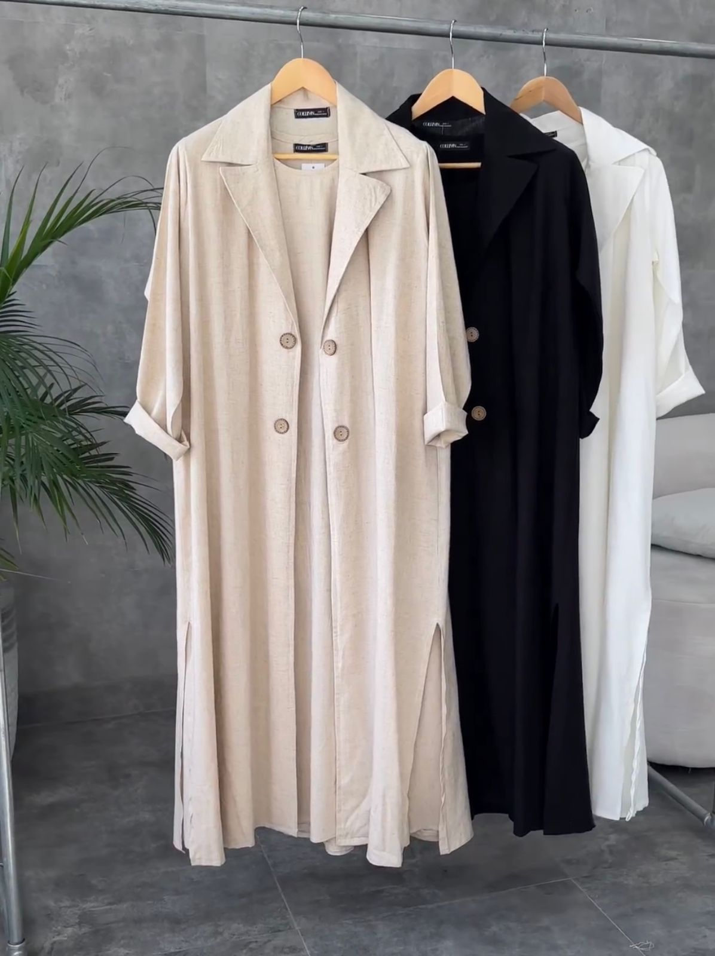
NAME | Rimsha Iqbal
NUMBER | 03365448734
ADDRESS | Faculty of Management Sciences Riphah International University Al-Mizan Campus | 274 Peshawar Road | Saddar | Rawalpindi | Pakistan, RAWALPINDI, Pakistan
SIZE | Large / Skin
S. STRUC
AMOUNT | 6,000.00 PKR
TAGS | Call Confirmed

Order #15378
Riski | Product 1 of 2: Matching Stole | (No image available)
NAME | Rimsha Iqbal | (No image available)
NUMBER | 03365448734 | (No image available)
ADDRESS | Faculty of Management Sciences Riphah International Univ⁷ersity Al-Mizan Campus | 274 Peshawar Road | Saddar | Rawalpindi | Pakistan, RAWALPINDI, Pakistan | (No image available)
SIZE | N/A | (No image available)
S. STRUC |  | (No image available)
AMOUNT | 1,500.00 PKR | (No image available)
TAGS | Call Confirmed | (No image available)

Riski | Product 2 of 2: Linen Two-Piece Set – Inner & Gown
NAME | Rimsha Iqbal
NUMBER | 03365448734
ADDRESS | Faculty of Management Sciences Riphah International Univ⁷ersity Al-Mizan Campus | 274 Peshawar Road | Saddar | Rawalpindi | Pakistan, RAWALPINDI, Pakistan
SIZE | Xlarge / Skin
S. STRUC
AMOUNT | 6,000.00 PKR
TAGS | Call Confirmed

Order #15377
Riski | Product 1 of 1: Graceful Draped Gown | 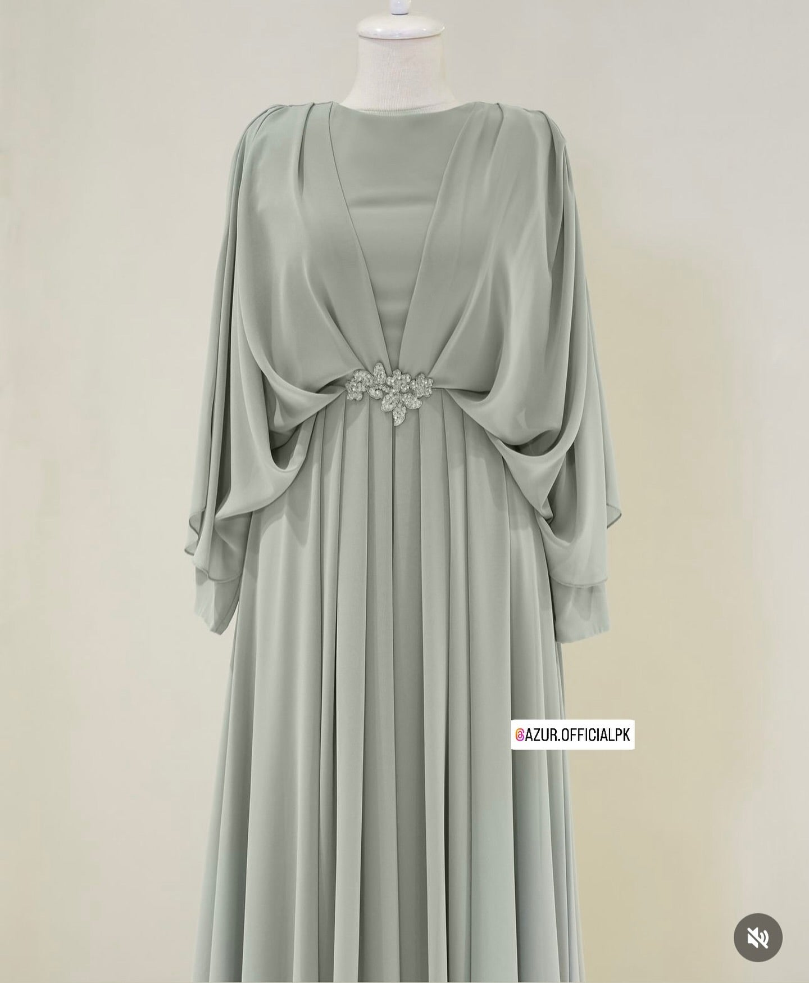
NAME | Bina Hassan
NUMBER | +923030960399
ADDRESS | S-17,banglow khayaban e abdali DHA phase8 opposite creek vista apartment karachi, Karachi, Pakistan
SIZE | Xlarge / Light Pink
S. STRUC
AMOUNT | 6,000.00 PKR
TAGS | Call Confirmed

